

000113600261
ҰЗАҚБАЙ Жайна Жаңабайқызы,
Сырбек Каттебеков атындағы жалпы
білім беретін мектебінің ағылшын тілі пәні мұғалімі.
Түркістан облысы, Шардара ауданы

MY COUNTRY. AN ADVENTURE HOLIDAY

Learning objectives | 6.1.1.1 use speaking and listening skills to solve problems creatively and cooperatively in groups  6.2.4.1 understand the main points of supported extended talk on a range of general and curricular topics  6.4.5.1 deduce meaning from context in short texts on a limited range of familiar general and curricular topics
Lesson objectives | Learners will be able to:  • Read a text about white-water rafting in Kazakhstan  • Talk about different types of holiday  • Learn how to talk about the future using could, may and might  • Write about a holiday
Value links | Patience – A person who has patience as a core personal value is going to prioritize giving their time to others. They will sit down and be calm while waiting for others. This is a great trait for a teacher.
Plan

Stages / Time | Teachers’ actions | Students’ actions | Assessment criteria | Resources
Beginning of the lesson  7 min | Organization moment  1.Greeting.  Ask about the weather.  The teacher sets the lesson objectives, letting students know what to anticipate from the lesson.  Warm-up  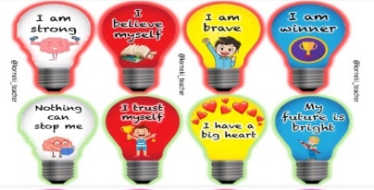  students wish each other by holding a wishes lamp  Lead – In  Books closed. Put students into groups and write Holidays on the board.  Give students two minutes to tell each other where they went on their last holiday and what they did.  Dividing into three groups by method «suitcase division».  T:open the envelop and ask students to take the cards. They should find their team according to the number:  1.First 2. Second 3.Third  Task 1. Checking home task. Game with velcro “Travel equipment”.  What was your home task? Match the words with pictures. Check students’ answers. | The aim: To develop pupils speaking skills and create friendly atmosphere  Efficiency: By telling the wishes they show their appreciations .  Students of the class are listed.  Students' attention is drawn to the lesson.  Students analyze the given pictures in pairs.  Determines the topic and purpose of the lesson  Students say different words from the picture  Students sit on their group.  Students match the pairs and try to give the correct answers. | At the organization moment teacher tries to award active pupils. «The praise» method is used to evaluate pupils with phrases like:  “Good job!  Well done!”  Formative Assessment    Good job!  Descriptor:  - match the words with picture  - answering correctly | Pictures  Student’s book  Flashcards  Mobile phone  Velcro cards
Middle of the lesson  35 min  Individual work  Pair work  Group work | Task 2. Method «Quizlet »  Work with vocabulary-Context Clues  Activity holiday- белскнді демалыс  Adventure holiday- шытырман оқиғалы демалыс  Beach holiday- жағажай демалысы  Camping holiday- кемпинг демалысы  City break- қала демалысы  Sightseeing holiday- экскурсиялық демалыс  Skiing holiday-шаңғы демалысы  Self-catering- өзін-өзі тамақтандыру  Task 3. Watch the video.  Show Ss video about an adventure holiday and useful vocabulary.  Ask general questions after watching.  What do you do in your holidays?  Why are holidays important to you?  Task 4. Ex: 1 P: 76 Work on the platform wordwall.  • Focus students’ attention on the words in the box.  • Ask them to remember what people said about their holiday and to match the words to people in their group.  • Elicit from the class what you do on each type of holiday, or explain if they don’t know.  • Then students go back into their groups and discuss questions 2–4. • Monitor and give help where needed.  • Get feedback by asking a few different students to tell you what their group discussed.  Task 5. Listen to the text and write true or false on the platform educaplay. Ex: 3 P:76  T: Read the text and do the task  True/False task  Scanning  Low- motivated SS  Ss-underline words from text  Intensive reading  High motivated Ss-  True/false- rewrite False sentences into True  Task 6. Method «Mind map »  T:Let’s make up the mind map about An adventure holiday  Make as many sentences as you can.  Begin your sentences “I think….  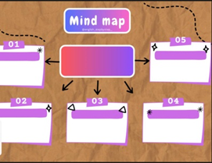  Task 7. Game with Velcro.  T:Let’s play the game with velcros.  Match the words with pictures.  Check students’ answers  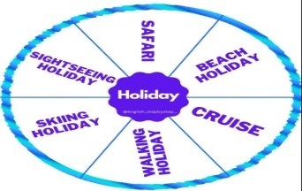 | Ss get familiar with new words and sort the known and unknown words to themselves.  Ss watch the video. Work with new words and phrases. Answer to the T’s questions.  Students look at the types of holiday in the box and answer the questions.  ANSWERS:  Student’s own answers.  Students read and listen to the text and write true or false. Correct the false sentences.  ANSWERS:  1 False. Children can try it if they are with an adult.  2 True  3 False. You will get wet.  4 False. You should wear a swimming costume under your clothes, such as shorts or tracksuit bottoms and a sweatshirt.  5 True  6 false  Ss work in groups and make up the mind map.  And students develop research and public speaking skills.  Answers:  Students own answer  Students match the pairs and try to give the correct answers. | Assessment criteria  - Talk about  different types of  holiday  Descriptor:  - look at the types of holiday in the box and answer the questions.  Descriptor:  - read the text  - correct the false one  Descriptor:  - work in group  -make up the mind map  Descriptor:  - match the words with photos  - answering correctly |   https://quizlet.com/878875503/an-adventure-hoiliday-flash-cards/?i=5bn4eq&x=1jqt  Cards  https://wordwall.net/ru/resource/63269897  Student’s book  Worksheets  https://www.educaplay.com/learning-resources/17828888-true_false.html  mind map  Cards velcro
End of the lesson  3 min | FEEDBACK  Learners provide feedback on what they have learned at the lesson.  This is a way for students to self-reflect on their progress in the lesson.  Home task:  Ex: 2 P: 52 WB | 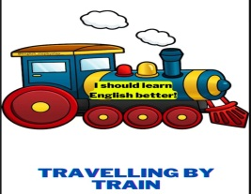 |  | Poster  

